Emergency
Management
Plan
Collectively Kids Ltd
Address | 28 Carrington Rd  Mt Albert  Auckland 1025
Contact details | Phone: 098495261 02127366059  Email: collectivelykids@xtra.co.nz  Website: collectivelykids.com
ECE Emergency contacts | Name: Marina Bachmann  Role: Manager/Professional leader Phone: 093788236  Mobile: 02102990301
John Nicol (Caretaker) 09 3788236, 021 0411506
Soya Thomas (Senior teacher) 0211638986
Radio | - National Radio  756 AM OR 101.4 FM  - Newstalk ZB  89.4 FM  - Classic Hits  97.4 FM  - More FM  91.8 FM  - Radio Live  702 AM OR 100.6 FM
Last revised | 10/11/2023
Next review | November 2024

Contents

Contents 3
Introduction 4
Basic emergency response process 4
Site map 5
Calendar - planned drills and other training 6
Our role in a Civil Defence emergency 6
Emergency contact plan – parents and caregivers 6
External contact lists – last updated: 5/9/2022 7
Emergency services contact information 7
Essential government contact information 7
External contact lists – last updated: 5/9/2023 9
Essential utility contact information 9
Essential security contact information 9
Other miscellaneous contact information 9
Local ECE services/schools contact information 10
Emergency Response Types 11
Evacuation 11
General evacuation plan 11
Evacuation areas 12
Fire 13
Earthquake 17
Tsunami Error! Bookmark not defined.
Flooding 20
Volcanic eruption and ashfall 21
Pandemic 22
Chemical spill 23
Severe Weather event 23
Dealing with a suspicious letter or package 24
Bomb threats 25
Trespasser on the grounds 27
Attacker on-site 28
Serious injury or death 30
Online resources 30
Traumatic Incident Team 30
Missing child or student 31

Introduction
This plan outlines how Collectively Kids will respond in the event of an emergency.

Basic emergency response process
While every event is unique, there are some basic steps to follow when responding to any emergency, which are outlined below:
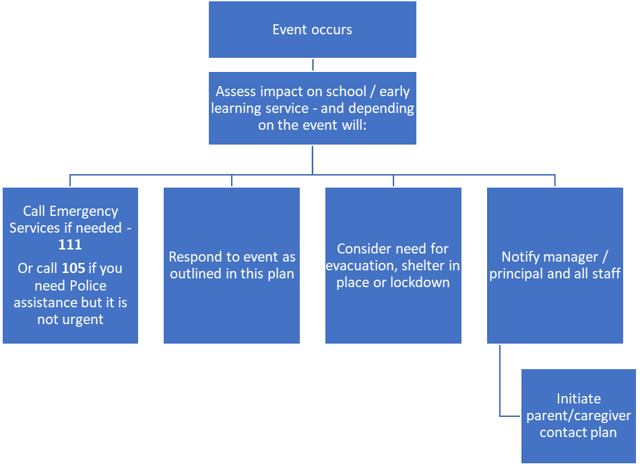

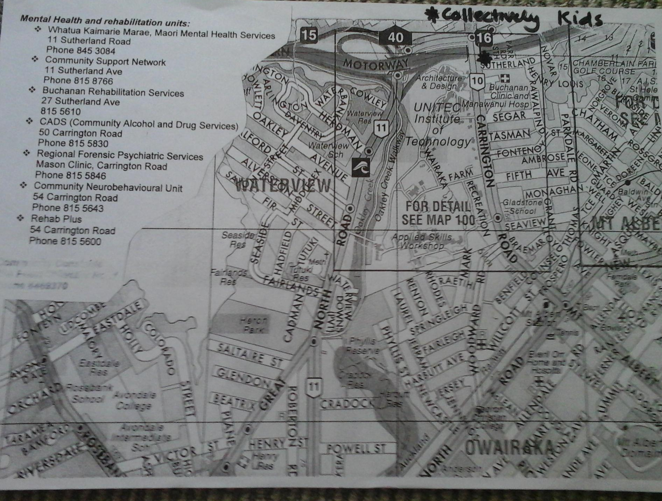
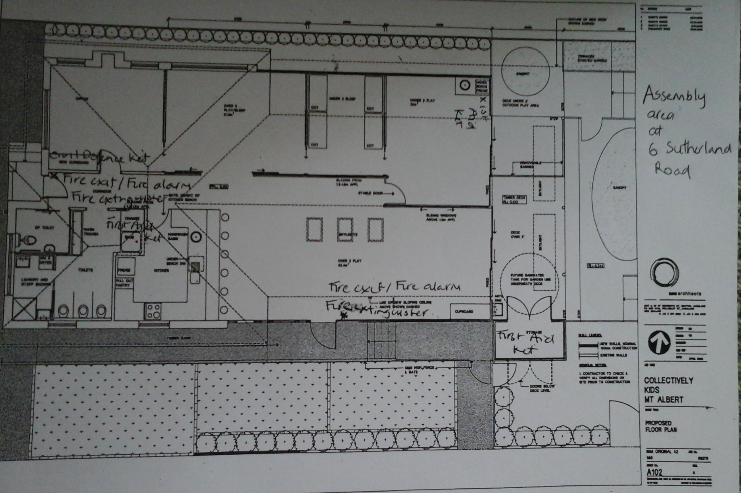
Site map

Calendar - planned drills and other training
These are recorded on the Drive

Our role in a Civil Defence emergency
Civil defence preparedness for Collectively Kids and schools generally is focused on ensuring the safety of students and staff at the workplace during a civil defence emergency

Emergency contact plan – parents and caregivers

Our emergency contact plan for parents and caregivers
In case of an emergency parents/caregivers will be advised via a text message from our SMS messaging system or phone call. All contact details are on the CK phone and updated in our SMS. A contact list is also in the emergency folder, in the grab bags and on the office noticeboard.
Monitoring of pick up of children by parents/caregivers or emergency contacts.
The daily register will be used if it is available, alternatively pick-ups will be recorded in writing.

External contact lists – last updated: 10/11/2023
Where possible include a primary and alternate number.

Emergency services contact information
Police, Fire, Ambulance | 111  105 for Police, if needing non-urgent assistance
Police Avondale | Phone: 09 8204610
Local Emergency Management office/group (Civil Defence) | For Civil Defence information call 0800 22 22 00 or contact the Auckland Council on 09 301 0101  Civil Defence app is on CK phone
National Poison centre | Urgent line 0800 764 766  Non-urgent 03 479 7284
Med Centre | Pt Chev Medical Centre  1181 Great North Rd  Phone: 09 8466244  St Lukes White Cross  52 St Lukes Rd  Phone: 8153111

Essential government contact information
Medical Officer of Health (local Public Health Unit) | Auckland Regional Public Health Service  096234600  info@health.govt.nz
Ministry of Education | Local office - 09 632 9400  Traumatic Incident Team - 0800 TI Team (0800 848 326)  Contact Centre - 0800 225 580  National Office - (04) 463 8000
Ministry of Education media advice and assistance | Point of contact Senior Media Advisor, Communications Group  Phone 04 463 8000 / After Hours 027 560 5387
Mataara – the emergency contact system operated by the Ministry of Education | Go to – education.govt.nz for more information about Mataara.
Oranga Tamariki Ministry for Children | 0508 326 459

External contact lists – last updated: 5/9/2023

Essential utility contact information
Power company Meridian  Vector lines | Account number: 11376521  Phone: faults 0800 496 596  0800734567
Grammar Electrical and  Wompanies and water Works are linked | 098846611 0800448372  W: www.grammarelectrical.co.nz  W: www.water-works.co.nz
Builder / handyman John Nicol | 09 3788236, 021 0411506
Plumber water tanks | Glenn – 027 478 0 895

Essential security contact information
Security | For alarm call outs – First Security through Chubb
Alarm monitoring Chubb | 0800 804 445  Tech 0800432625
Fire alarm/equipment maintenance | Fire Control Services 0800 352637

Other miscellaneous contact information
 | Contact details
Lawyer | Erich Bachmann 09 375 8709, 09 309 0552  021827087
Insurance | Paramount 09 360 3292

Local ECE services/schools contact information
Other schools/ECEs in local area | Contact details
School: Gladstone | Phone: 09 846 9744
School: St Francis | Phone 09 846 469
School: Pt Chevalier | Phone: 09 846 1359

Emergency Response Types

Evacuation
Evacuation from the early learning service may be required to ensure the safety of staff and students in an emergency event. In all cases, evacuations need to be planned and practiced.

General evacuation plan
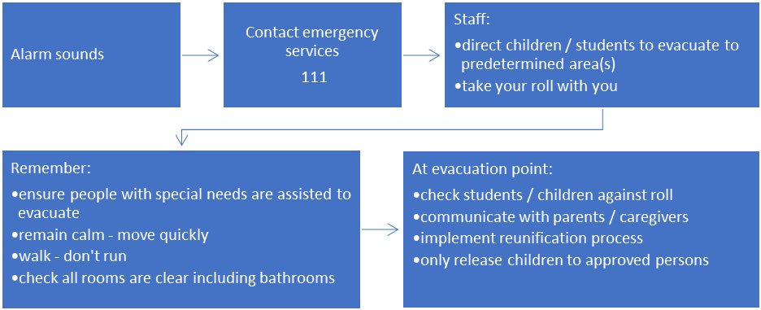

Specific events
Following an evacuation
Do not return to the early learning service site until given clearance to do so.
Whether the early learning service can continue to operate that day (and in the future) will be determined by:
The nature of the event
The safety of the buildings and other facilities including running water, power, heating etc
Health and wellbeing of staff.

Deciding whether or not to continue operating following an event rests with the early learning service manager / operator. Appropriate advice from professionals should be sought if needed.

Contact the Ministry of Education if you need support.

Bomb threat
Keep at least 100m from the area where the package was found

Evacuation areas

Our evacuation areas

Fire Evacuation Plan / Point
Ensure that all staff, customers and other visitors proceed to the assembly area. Which is the footpath outside 6 Sutherland Road.

Earthquake Evacuation Plan / Point – Whatua Kaimarie car park as far as possible from trees and power lines.

Tsunami Evacuation Plan / Point – Tsunami – unlikely to occur in the area.

Volcano Evacuation Plan / Point

In most cases it is advisable to stay indoors during ashfall.

Gas/Chemical Evacuation Plan / Point – this would depend on where source was. If it was not in our building we would close all windows and doors and wait for advice. If it is in our building we would evacuate and take asthma medications and spacers.

NB this may require a “silent” alarm i.e. no cell phones or alarms.

Fire
This checklist outlines what to do in the event of fire. You can also use it when practicing a fire drill.
 | Response actions (as appropriate)
Discovery of a fire | □ Ring the fire alarm.
□ Call 111
Ask the operator for the Fire Service. When connected to the Fire Service inform the operator of a fire at:

Collectively Kids
28 Carrington Rd
Pt Chevalier
(corner of Sutherland Road)

Give the operator the precise location of the fire and any other useful information you have. It may not be possible to use the phone from your particular area, therefore ring once you have left the building, from a neighbouring building or a mobile phone.

DO NOT PANIC!
 | □ If safe to do so extinguish the fire – see use of fire extinguishers below
On hearing the alarm | □ Under two teachers should exit via the garden gate and advise outdoor teacher as the alarm can be hard to hear. Warden/teacher closest to the kitchen take will register.
 | □Teachers should guide children to the exit that is the furthest from the fire.
 | □ Walk calmly and quickly and avoid panic.
 | □ Ensure students / visitors with disabilities are assisted by a responsible person.
 | □ Ensure any visitors are included in the evacuation.
 | □ Check rest areas, bathrooms and common rooms en route to the designated exit point.
 | □ Ensure all students remain at the evacuation point until clearance to leave is given.
Returning  to the building(s) | Do not return to the building(s) until given the all clear by the Fire Service.
Ongoing operations following a fire | The continuing operation of Collectively Kids will be determined by the nature of the fire and the availability of resources such as buildings, staff, employees and other resources  The responsibility of whether or not to continue operations at Collectively Kids rests with the Manager.

Evacuation checklist

Area | Floor Warden | Deputy Floor Warden
OFFICE / TOILETS | Teachers designated as person responsible on the day | Teachers designated as person responsible on the day
SLEEP ROOM | Teachers designated as person responsible on the day | Teachers designated as person responsible on the day
UNDER TWO’S AREA | Teachers designated as person responsible on the day | Teachers designated as person responsible on the day
OVER TWO’S AREA | Teachers designated as person responsible on the day | Teachers designated as person responsible on the day
OUTSIDE PLAY AREA | Teachers designated as person responsible on the day | Teachers designated as person responsible on the day

FIRST AID FIRE FIGHTING EQUIPMENT

There are fire extinguishers available throughout this building. All occupants must be familiar with the location and use of the firefighting equipment in their area. A fire extinguisher is designed to put out small fires only.

Fire is a chemical process that requires three things to keep burning, fuel, heat and oxygen. Remove any one or more of the three and the fire will go out. This sounds simple but in reality fire is fast moving, hot and frightening. A small flame can turn into a large fire in seconds.

To determine if it is safe to use an extinguisher or hose:
Is the fire small enough to be put out by a fire extinguisher?
Is the extinguisher or hose suitable for extinguishing the class of fire?
Will attempting to extinguish the fire endanger anyone’s life?
Is there unrestricted access to the fire?
Will there be a quick, unrestricted retreat available at all times?

The safety of all building occupants must always be the first consideration. Before using an extinguisher ensure that:

The fire alarm has been activated and people are evacuating the building.
A 111 call to the Fire Service has been made.
Wardens’ search their designated area.
Never delay calling 111 while trying to put out a fire. For the Fire Service to arrive in time to help they must be called at the earliest possible opportunity.
Unless it is a small and controlled fire, fire fighting is best left to the professional fire fighters. They have the training, experience and equipment to deal with the emergency. Fire fighters know about “hot spots”, places where fire may still be burning but not noticeably so and “flare ups”, fires that start again, sometimes hours later.
Read the instructions on operating procedures before an emergency arises.
Always have somebody stand-by as a backup when you operate a fire extinguisher

HOW TO USE A FIRE EXTINGUISHER

Make the extinguisher ready for use by breaking the seal, or if applicable, removing the pin.
Aim the extinguisher at the base of the fire. Keep low to minimise the effects of heat and smoke.
When in position, start discharging the extinguisher in a sweeping motion across the base of the fire.
If at any time the fire becomes uncontrollable or there is too much heat and smoke for comfort, leave immediately and close the doors behind you if possible.

ALWAYS STAY BETWEEN THE FIRE AND THE DOOR!

CLASSES OF FIRE

Fire is divided into six classes for the purposes of effective suppression. These classes are related to the materials on fire and have an impact on the type of extinguisher to be used. The table below shows how to identify the classes of fire and the most suitable extinguisher.

CLASS OF FIRE | SUITABLE EXTINGUISHER
CLASS A:  Materials such as wood, paper and  textiles | Fire Hose reel, water filled extinguishers or multi-purpose dry powder extinguishers.
CLASS B:  Flammable liquids such as petrol, oils,  cooking fats and solvents | Dry powder or multi-purpose extinguishers, carbon dioxide, foam or light water extinguishers
CLASS C:  Gases such as acetylene, LPG, CNG  and natural gases | TURN OFF THE GAS SUPPLY FIRST.  Use a multi-purpose dry powder extinguisher
CLASS D:  Metals such as sodium, potassium and magnesium | Special dry powder extinguisher.
CLASS E:  Fires in electrically energised equipment of any other class of fire | TURN OFF THE ELECTRICITY FIRST.  Dry powder or multi-purpose extinguishers, carbon dioxide extinguishers.
CLASS F:  Fire involving cooking fats and oils | Dry powder or multi-purpose extinguishers, carbon dioxide extinguishers.

REMEMBER: NEVER USE A FIRE HOSE OR A WATER EXTINGUISHER TO PUT OUT A FIRE INVOLVING ELECTRICITY OR BURNING LIQUIDS

Earthquake

This checklist outlines what to do in the event of an emergency. You can also use it when practising an earthquake drill. REMEMBER – LONG OR STRONG, GET GONE
 | Response actions (as appropriate)
During an earthquake | □ If indoors:  Over 2 area  - Drop, take cover under a desk or table and to hold onto the legs until the shaking stops  - Drop into turtle position if no tables are nearby  - Keep away from shelves containing heavy objects and other large items of furniture  - Keep away from windows  - Stay indoors until the shaking stops and it's safe to go outside  Infant/toddler room  - If possible teachers will move children under kai table and then drop into turtle position  - If this is not possible teachers will cover children with their bodies  - Keep away from shelves containing heavy objects and other large items of furniture  - Keep away from windows  - Stay indoors until the shaking stops and it's safe to go outside
□ If outside:
Drop and cover
Keep away from climbing boxes and moveable outdoor equipment
- Students are to stay in the school grounds until a teacher comes to get them.
- Keep away from buildings and power lines
When the shaking  stops | □ Ensure your personal safety first
 | □ Check those around you and offer help if necessary.
 | □ If anyone requires medical assistance, call 111 and/or administer first aid.
 | □ Evacuate if required.
 | □ Get staff and pupils away from dangerous areas
□ If the ECE/school is located near the coast line or a large body of inland water, be aware of the possible risk of Tsunami
The risk of a Tsunami in our location is minimal (checked with Civil Defence 2015 and again in 2023)
 | □ Listen to the radio for instructions from Civil Defence.
 | □ If you smell gas or hear a blowing or hissing noise, open a window and get everyone out quickly. Turn off the gas, using the outside main valve if you can. If you turn off the gas for any reason, it must ONLY be turned back on by a registered plumber or gas fitter.
Ongoing operations following the earthquake | □ The continuing operation of Collectively Kids will be determined by the nature of the emergency and the availability of resources such as buildings, staff, employees and other resources.  The responsibility of whether or not to continue school functions rests with the Manager in consultation with the Senior Teaching Team.
 | Contact the Ministry of Education regional office (they can provide support through the Traumatic Incident team if required).

 | Response actions (as appropriate)
When a tsunami  threatens | □ Listen to your radio or TV for advice and information
If you feel a long (more than a minute) or strong (hard to stand up) earthquake and the school / early learning service is in a tsunami evacuation zone:
Once the shaking stops, gather all students / children and evacuate immediately; move to higher ground or as far inland as possible
If you receive an official warning advising you to leave. Respond to the first message; do not wait for more messages before you act
- Listen carefully to official instructions and follow them
- Evacuate from the areas or zone(s) stated in an official warning.
- If there is time, take your disaster survival kit and any important documents with you (such as the roll and contact details).

- Stay out of the evacuated area until given the official “all-clear”. Continue to listen to TV and radio or monitor civil defence social media for advice and information.
Contact the Ministry of Education regional office for support, if needed.

Flooding
Flooding can happen quickly and have serious impacts. Flooding may be caused by heavy rain, overflowing creeks and rivers and high tides or tsunamis in coastal and low-lying areas.
Floods within a building can also be caused by normal wear and tear failures of pipe joints, vandalism, or be the result of earthquakes.
 | Response actions (as appropriate)
Flooding reported or sighted | Be ready to act quickly. Floods and flash floods can happen quickly and without warning.  Evacuate if required (and get to higher ground).  Follow the instructions and advice of emergency services and civil defence and emergency management authorities.  If safe to do so, move records and equipment onto higher floors or onto furniture as high as possible.  If flood is due to burst pipes, etc, turn off the water at the mains if possible.
After a flood | Flood dangers do not end when the water begins to recede. Continue to listen to communication channels and don’t return until authorities indicate it is safe to do so.  Get medical care if necessary. Contaminated water can cause infection.  Stay away from damaged areas. Your presence might hamper rescue and other emergency service operations.  Contact the Ministry of Education regional office (they can provide support through the Traumatic Incident team if required).

Volcanic eruption and ashfall
If you are at risk from volcanic activity:
- Learn about your community’s warning systems and emergency plans
- Develop an evacuation plan for volcanic eruptions and make sure everyone is aware and practices it.

 | Response actions (as appropriate)
When a volcano threatens | □ Listen to your radio or TV for advice and information
 | □ Contact your local Civil Defence Group for advice.
 | □ Check that staff know what to do. Revise with students.
Large eruption | □ Evacuation: If the school is in the path of potential lava flows, pyroclastic flows, surges or lahars be prepared to evacuate when asked to by controlling authorities (i.e. police, civil defence, etc).
Ash Fall | □ Ensure that staff and pupils stay indoors. Have dust masks available.
 | □ Close windows and doors. In heavy ash falls, windows and doors may need additional sealing to avoid ash entering the CK building.
 | □ Turn off air-conditioning units and any other equipment that draws in or blows air.
 | □ Protective clothing (especially if working in the ash fall) should be worn by anyone who has to work outside in an emergency and goggles used to protect the eyes.
 | □ Monitor the amount of ash on roofs. Roofs may collapse under the weight of ash causing injury to the occupants. Evacuate buildings which show signs of roof sagging.
 | □ Disconnect roof-fed water supply only when ash fall is occurring or during the clean up to stop ash entering the storage tanks.
 | □ If possible have school outdoor equipment, cars, etc parked under-cover or cover them.
Cleaning up after an ash fall | The local council and CDEM group will provide advice on cleaning up and disposing of ash.
Seek support if needed | Contact the Ministry of Education regional office (they can provide support through the Traumatic Incident team if required).

Pandemic
Pandemics by their nature are unpredictable in terms of timing, severity and the population groups that are most affected. Planning for an infectious disease outbreak is as important as planning for other emergencies.
It is important that CK takes steps now to protect staff, students or children from future pandemics (global disease events such as influenza) or epidemics (local disease events such as, measles, hepatitis, tuberculosis, norovirus, whooping cough etc).
The Ministry of Health leads the Government’s response to a pandemic. It is the responsibility of other agencies to plan for and respond to a pandemic in their respective sectors and settings, based on the direction set out by the Ministry of Health. At all times updates and latest information should be accessed from the Ministry of Health.
Pre-response and Response actions (as appropriate)
Planning | Recommend / fund annual vaccinations for staff.  Consider having a supply of Personal Protective Equipment (PPE) gloves, face masks, antiseptic hand wash.  Develop a communications plan for staff, students, children, families and other interested members of the community.  Identify an appropriate space to be used as an isolation area.  Know who the local Medical Officer of Health is and maintain regular contact.
Response - when a pandemic has been advised or declared | Regularly check for updates on the Ministry of Health website (Ministry of Health NZ).  Use posters available from Ministry of Health re cough / sneeze etiquette, handwashing.  Consider physical distancing strategies and ventilation. Information on this is available from the Ministry of Health.  Consider implementing an enhanced cleaning routine of touch points and common spaces as a precaution.  Establish the isolation area (as required).
Liaise with the local Medical Officer of Health as needed (see Essential agency / service contact list for details).
Ensure that a comprehensive plan is drawn up and clearly communicated with whānau.
The Ministry of Education website has further guidance for schools and early learning services to plan for a pandemic – education.govt.nz.

Chemical spill
All chemical spills must be treated as toxic and dangerous. They can be in liquid form, solids, powder or gas.
 | Response actions (as appropriate)
Become aware of chemical spill | □ Move all people in the vicinity to a safe area. Consider:  - evacuation of entire centre if required and safe to do so  - alternatively, it may be safer to stay indoors and seal doors, windows, other openings and switch off any air intake units.
 | □ If required, contact emergency services on 111
 | □ Give appropriate first aid to anyone in contact with the spill
 | □ Notify the Manager or person in charge and staff
 | □ Children will stay at the centre until it is safe for them to leave. If the event continues after 5.30 (centre closing time) or traffic has been affected and parents/caregivers are unable to pick up, teachers will remain on site to ensure that ratios are met for the remaining children.

Severe Weather event
Severe weather events can affect the ECE centre and pick-up of children
 | Response actions (as appropriate)
Become aware of storm/unusual  weather event | □ Move all people inside  - Close windows and doors  Check civil defence alerts
 | □ If required, contact emergency services on 111
 | □ Give appropriate first aid to anyone who has been injured
□ Notify the Manager and staff
- Notify families of the situation advising them to take their time when travelling
 | □ If the weather event continues after 5.30 (centre closing time) or traffic has been affected and parents/caregivers are unable to pick up teachers will remain on site to ensure that ratios are met for the remaining children.

Dealing with a suspicious letter or package
When dealing with suspicious packages the utmost caution must be exercised and no attempts must be made to touch, move or examine the package.
 | Response actions (as appropriate)
In general | □ Note the location of the package and a description of it (markings, etc).
 | □ Do not touch, shake or attempt to move the package.
 | □ Check with the addressee to see if they are expecting the package.
 | □ Isolate the item.
 | □ Call the police (111) and advise them of the circumstances, the description of the package and its location. Note: If a suspected bomb - do not use a cell phone or other radio device anywhere near the package.
 | □ As appropriate, position staff at a safe distance to direct people away from the area where package/letter is.
 | □ Consider evacuating the area or the school (Take police advice)
If you open a letter/package and discover powder: | □ Put on gloves and place opened letter/package in a plastic bag
 | □ If hands or any part of the body may have come into contact with the envelope or package then wash with soap and water
□ If contents spilled
- Do not clean up or wipe spilt contents
- Avoid breathing the powder or spores
- Clear and isolate the area
- Switch off air conditioning
- Wash hands with soap and hot water.
□ If contents are spilt on clothing
- Select a room for changing
- Remove clothing and place in plastic bag
- Shower with soap and hot water
- Change into other clothes.
See New Zealand Police Suspicious letter or package for further information.

Bomb threats
Keep calm. Do not hang up. A dialogue with the caller is important as information that may be gleaned from the caller can help assess the current situation and help police with further inquires.
Let the caller talk, ask the questions below as the opportunity arises and avoid being confrontational. Try to record as much information about the caller as you can.

Following the call:
Call 111 and explain the situation to the police. It is likely that they will advise you on what to do next. The decision to evacuate or stay within a building will depend on the circumstances of the threat. More information from New Zealand Police can be found here: Suspicious mail and bomb threats | New Zealand Police

Questions |  | Answers
When is the bomb going to explode?
Where is the bomb?
What does the bomb look like?
What kind of bomb is it?
What will make the bomb explode?
What is the explosive type and quantity?
Why did you place the bomb?
What is your name?
Where are you?
What is your address?
Exact wording of the threat:
The Caller
Gender: |  | □ Male □ Female
Estimated age:
Any speech impediment (specify):
Accent (specify):
Voice- loud – soft etc:
Speech – fast – slow etc:
Manner, calm emotional etc:
Did you recognise the voice? |  | □Yes □No
If so, who do you think it was?
Was the caller familiar with the area? |  | □Yes □No
Threat Language | Background noises | Call taken
□ Well spoken  □ Incoherent  □ Irrational  □ Taped  □ Message read by caller  □ Abusive  □ Other: | □ Street noise  □ House noise  □ Aircraft  □ Voices  □ Music  □ Machinery  □ Vehicle  □ Other: | Date: ___/___/_____  Time:  Length of call:  Number called:
Details of person taking the call
Name
Phone number
Signature _____________________________________ Date __ / ___ / _____

This checklist for bomb threats should be kept by the phone. Staff who would normally answer the phone should be briefed on the questionnaire to ensure some familiarity with it. A pre-printed version of the check list is available from police and may be preferred over this list for convenience.

Trespasser on the grounds
Only follow this process if it is clear that the trespasser does not come under the category of an attacker (see ‘Attacker on-site’).
Trespassing is where a person enters an ECE and either:
- Has been requested to leave, or
- their behaviour is such that the ECE would not give permission for them to be there.
Note: There is no authority under the Trespass Act 1980 for the occupier to physically eject the person from the premises. If a trespasser refuses to leave when requested, he or she should be told that the police will be called. The police have the option to arrest and charge the person with an offence, however they will assess each incident and take what they think is appropriate action.
As well as the process under the Trespass Act, the Education and Training Act 2020 sections 30 and 241 make it an offence to intentionally insult, abuse, or intimidate a teacher or staff member on school or early learning service premises (within the presence or hearing of any child / student of the service / school).
Incident type | Response actions (as appropriate)
You become aware of a person on the school / early learning service grounds that does not have permission to be there. | Assess the nature of the trespasser: non-threatening or aggressive (if aggressive – follow the attacker process, next page).  If appropriate, greet the trespasser, advise them who you are, and ask them why they are there. Whenever possible, ensure that you have a colleague with you.  If the reason for the visit appears legitimate, take the person to the office where the reasons for the visit can be dealt with.
Become aware that there is a trespasser on the property. | If the reason for the visit is not legitimate, explain that they have to leave the premises.  Notify the persons responsible or other staff member of the description, location and activity of the trespasser.  Ensure the children and staff are safe and the classrooms are kept secure.  If the person leaves when requested they are no longer considered a trespasser.
If the trespasser refuses to leave when requested | Explain that staff will have to call the police.  If the trespasser still refuses to leave ask a colleague to call the police.  If it is safe, stay with the trespasser until the police arrive.  If the trespasser gives any indication of violence walk away (if possible, keep the trespasser under observation from a safe distance until police arrive).  When police arrive update them on the situation.
Follow-up actions | Ensure the incident is documented and filed (including providing a report to police).  Contact the Ministry of Education regional office (which can help you access the Traumatic Incident team if required).  Consider:  - Debriefing staff on the incident and assess if the Emergency Management process worked correctly or needs amendments  - Debriefing children and students if the incident was a public one to prevent rumours and speculation.

Attacker on-site
This checklist provides a very basic guide to managing an attacker who is on-site.
The aftermath of an attack will require careful management as even in the ‘best case’ scenario of no one being injured there may be traumatised staff, children or students, concerned parents, disruption to your early learning service and media interest.
When responding to an attacker consider:
- Escape - Move quickly and quietly away from danger, but only if it is safe to do so
- Hide - Stay out of sight and silence your mobile phone
- Tell - Call the Police by dialling 111 when it is safe.
 | Response actions (as appropriate)
Shots are heard or a violent intruder is seen on the premises | □ Call 111  - Identify yourself and your ECE, including address  - Details of situation  - Details of any casualties  - Description of weapons, number of shots, etc  - Description and location and identity of offender if known  - Identify the 'target' of aggression if known
 | □ If safe, move to predetermined safe position to await Police arrival
- Alert staff/students (avoid using the fire alarm).
- Staff put mobile phones on silent.

 | □ Move to closest safe area, preferably an area that can be locked – baby room. Lock inside doors and windows if intruder is outside and move children away from doors/windows.
 | □ Lock and/or barricade, or cover if possible, doors/windows.
 | □ Keep quiet and do not leave the safe area unless it is safe to do so.
 | □ Should the event occur while children are outside move inside if possible and close all areas or evacuate children to Whatua Kaimarie Office.
 | □ Once police arrive, liaise with them to secure the scene(s)
Following the incident | □ The Trauma Incident Teams will provide support (see contact list for phone number).
 | □ Liaise with the media
 | □ Consider whether to temporarily close, or continue operating. (The Trauma Incident Teams will provide guidance on suitable responses)
 | □ Continue to monitor the wellbeing of students and staff

- Go to Appendix 1 of Planning and preparing for emergencies for further information to support planning for security-related events, including Escape | Hide | Tell.
- For detailed resources on traumatic incidents go to education.govt.nz
- Go to education.govt.nz for information on de-escalating a threatening situation

Serious injury or death
All early learning services and schools need to be prepared and know how to manage a traumatic incident involving death or serious injury. The sudden death (or serious injury) of a child, young person, staff member or family / whānau member can affect the physical and emotional wellbeing of children, young people and people within a community.
The event also has the potential to cause sudden and / or significant disruption to the effective operation of an early learning service, and their community. If the aftermath is poorly or insensitively handled, it can impact on those affected.
 | Response actions (as appropriate)
Death / serious injury occurs at ECE | □ Ensure your own safety. Assess area for danger (eg: live wires, poisonous substances, etc)
 | □ Do not assume death has occurred – give immediate first aid
 | □ Call emergency services on 111
 | □ Notify Manager/Senior Teacher; isolate and contain the area. Ensure access for emergency services.
Action after medical personnel have taken over | □ Senior Teacher to advise Manager if Manager is not at the centre
 | □ Manager to advise (as soon as possible) the Service provider contact and staff.
 | □ Consider accompanying police to advise parents or caregivers.
 | □ Ensure cultural supports are contacted so appropriate processes can be enabled.
 | □ Advise the Ministry of Education Trauma Incident Team on 0800 84 83 26. This team will help guide you on managing the response (including how to advise students, arrange counselling etc)
 | □ Complete incident form with all known details
 | □ Ensure the designated media person for the centre is fully briefed
If the death or serious injury occurs outside of ECE, follow the appropriate steps noted above.

Online resources
Visit the Ministry of Education website to assist in managing this type of response in ECE services:
www.education.govt.nz/school/student-support/emergencies

Traumatic Incident Team
Contact the Ministry of Education Traumatic Incident team on 0800-TI TEAM / 0800 84 83 26

Missing child or student
All instances of a child or student going missing from an ECE centre or an EOTC event have to be treated urgently and steps taken to find the missing person or confirm their safe whereabouts.
There can be many reasons and associated dangers for a missing child including:
- the proximity of dangerous hazards to the ECE
- the possibility of an abduction
- the possibility that the child has been picked up by a parent or caregiver.
- the child has got lost or left the facility.
Until the child or student has been found or confirmed in a safe location, action must be taken to locate them.
 | Response actions (as appropriate)
Information or notification that a child is missing | □ Confirm:  - that the person had been present at ECE at some time during the day, and if so;  - when they were last seen
 | □ Notify Manager and teachers
 | □ Search the ECE setting.
If child or student is found | □ If child found injured or ill, call for medical assistance if required.
 | □ Notify manager and other searchers.
 | □ Establish what happened and complete incident report
 | □ Arrange for the child’s parents or caregivers to be advised
If child or student is not found | □ Notify the police immediately
 | □ Notify the parents / caregivers immediately
 | Contact the Ministry of Education regional office for support

